

**Assignment**

**Comsats university Islamabad,Lahore Campus**

***Topic :***

**Console of**

**project**

Submitted by:

Umair Khalid, Hasham Aziz

Roll no:

SP24-BSE-119, SP24-BSE-041

Submitted to

Sir Shahid Bhatti

Date

14 Nov 2024

These are two consoles one is sever side and other client side.From now on I am gonna show only one bcz they are exactly same.

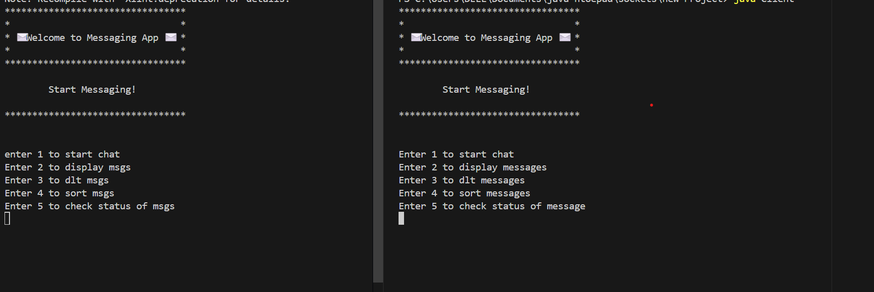I am entering 1 to add Contact

Now I am gonna display all available contacts

Now I am gonna send message to specific contact e.g.First contact

Now I am going to display all available msgs for specific number

I am entering 1 on both sides.Lets see what happens

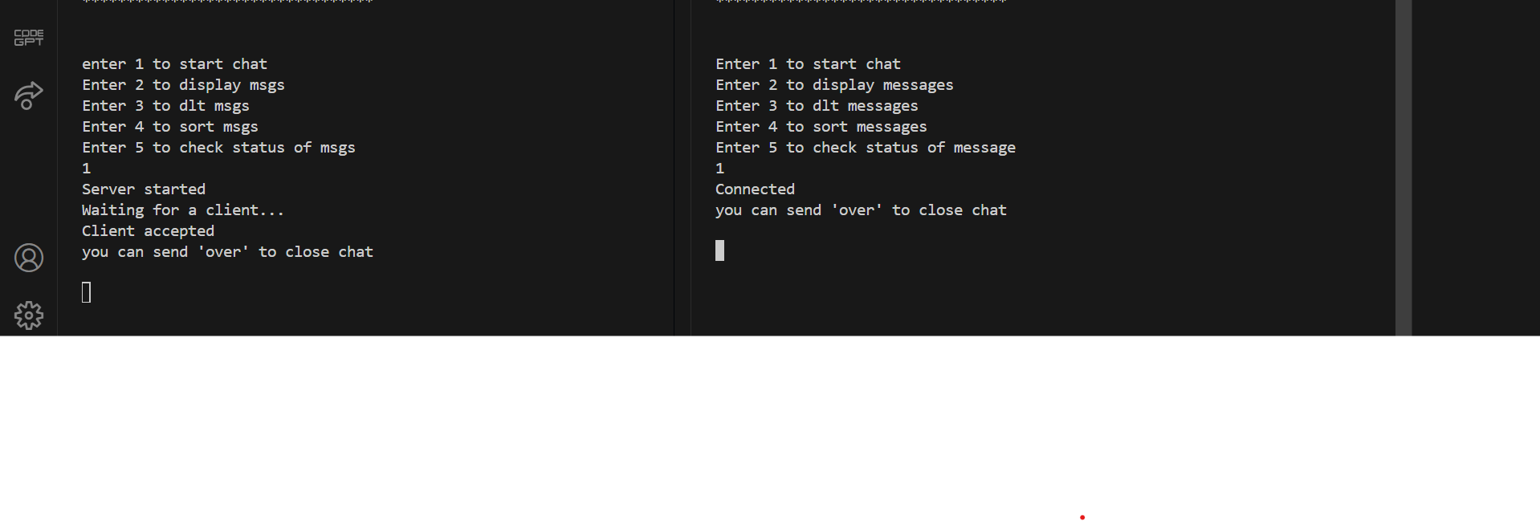

As we can see connection established successfully.Lets chat now.

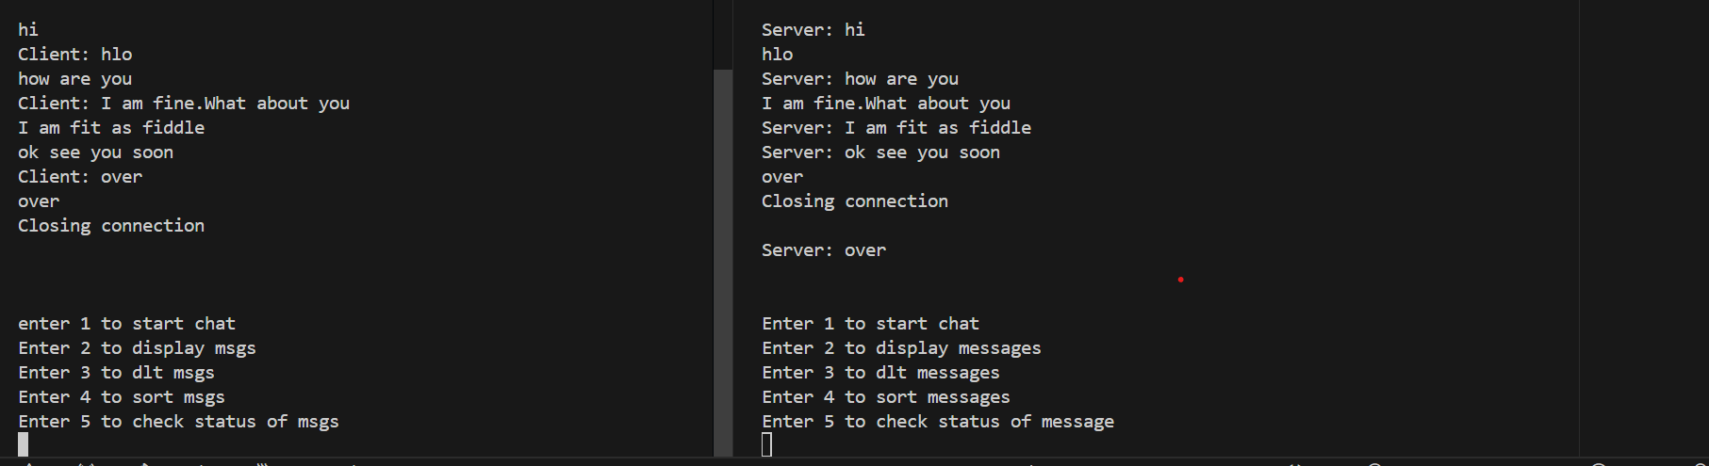

Chat completed successfully.

Lets check the other features.

Lets display all msgs First.

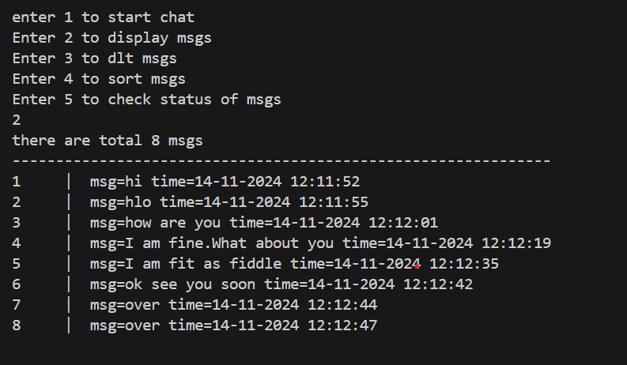

Msgs displayed successfully.Now lets sort all msgs by time

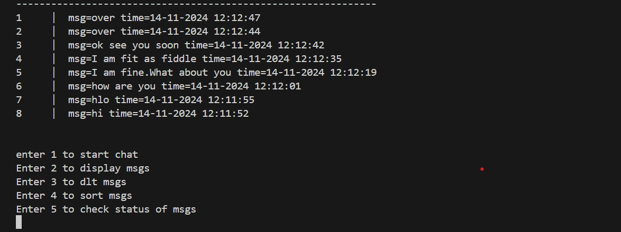

Msgs sorted by time successfully.

Lets check status of msgs that msgs are seen or not.

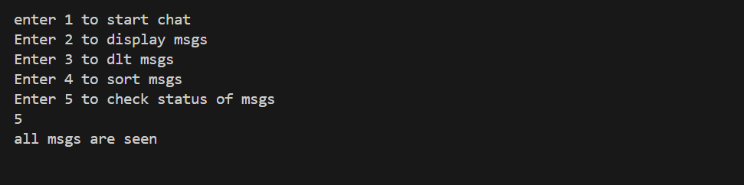

Now lets dlt msgs.I have added a feature to dlt messages one by one and all at once according to user choice.

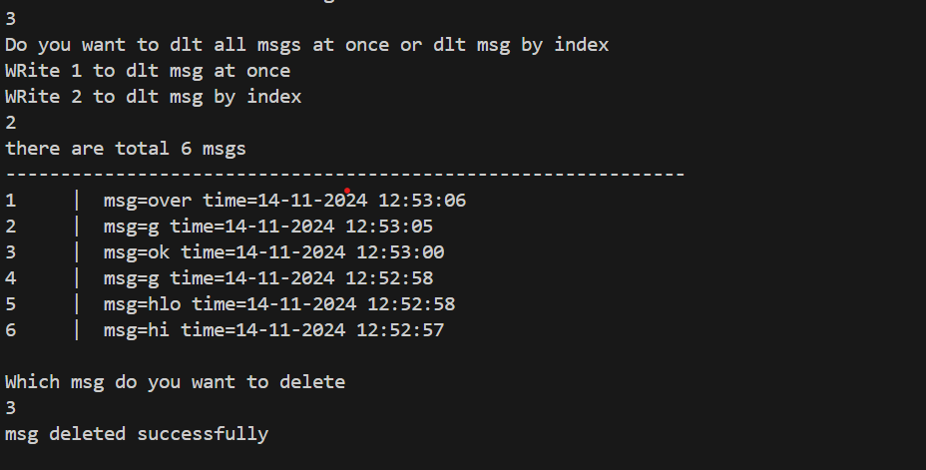

Lets check dlt all msgs at once feature

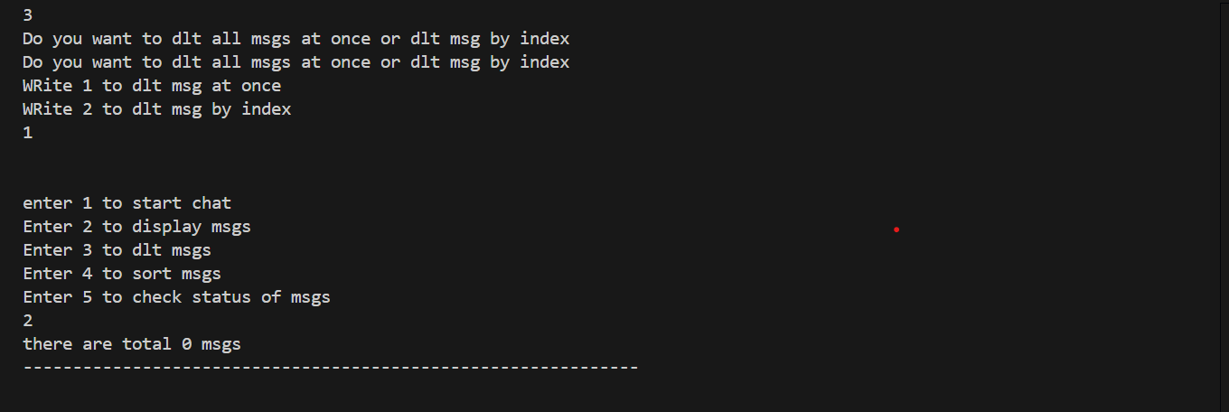

Everything is working totally fine.